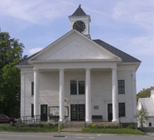
WARNING
Town of Danville Selectboard Meeting
Pursuant to 1 V.S.A. § 313
Danville Town Hall Conference Room
36 Route 2 West, Danville, VT

AGENDA

Tuesday, April 11, 2023 - 12:00 PM

12:00 PM - Call to Order

- Legal Matter (Executive Session 1VSA 313 (a)(1)(E)

1:00 PM – Adjourn

